**Homework 2**

**1**

**1.1** A dual-core ARM Cortex-A9 processor, and a set of associated processing resources forming an Application Processing Unit (APU), and further peripheral interfaces, cache memory, memory interfaces, interconnect, and clock generation circuitry.

**1.2** Programmable Logic in Zynq-7000 include: The logic fabric; Block RAMs for dense memory requirements; and DSP48E1 slices for high-speed arithmetic; General purpose input/output; Communications interfaces and other programmable logic external interfaces.

**1.3** One of communication between the PS and external interfaces, which provides 54 pins of flexible connectivity, meaning that the mapping between peripherals and pins can be defined as required.

**1.4** One of communication between the PS and external interfaces, which is not a direct path from the PS to external connections, but instead passes through and shares the I/O resources of the PL.

**1.5** AXI stands for Advanced eXtensible Interface, and the current version is AXI4, which is part of the ARM AMBA® 3.0 open standard. Many devices and IP blocks produced by third party manufacturers and developers are based on this standard.

**1.6** The general purpose input / output facilities (IOBs) on the Zynq are collectively referred to as SelectIO Resources, and these are organised into banks of 50 IOBs each. Each IOB contains one pad, which provides the physical connection to the outside world for a single input or output signal.

**1.7** General Purpose Input/Output (GPIO), which can be used for a variety of purposes including simple buttons, switches, and LEDs.

**2**

**2.1** 20x20=400 pins. (ug865 page33)

**2.2** 0.8 mm Pitch. (ug865 page78)

**2.3** 17 mm x 17 mm x 1.47mm. (ug865 page78)

**2.4** 128. (ug865 page11)

**2.5** 100. (ug865 page11)

**2.6** 48. (ug865 page11)

**3**

**3.1**

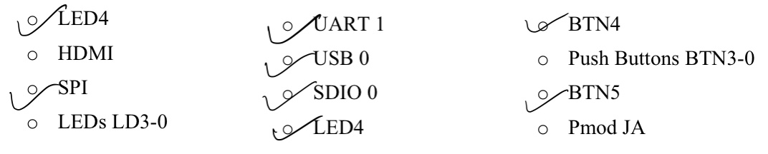

**3.2**

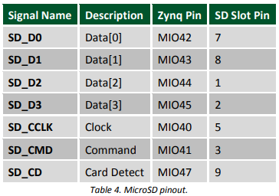

**3.3**

HDMI_HPD: E18

HDMI_SDA: G18

HDMI_SCL: G17

HDMI_CLK_N: H17

HDMI_CLK_P: H16

HDMI_D0_N: D20

HDMI_D0_P: D19

HDMI_D1_N: B20

HDMI_D1_P: C20

HDMI_D2_N: A20

HDMI_D2_P: B19

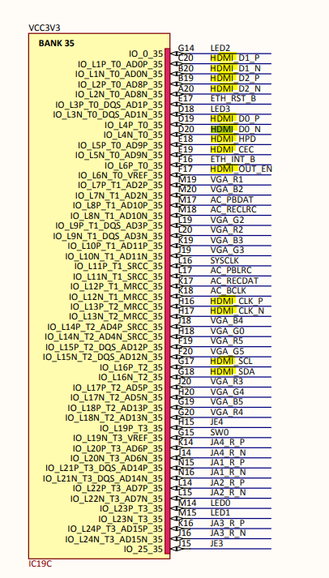

**4**

Printf() is provided by “stdio.h” , a part of c standard library. The source code of printf call write() or putc() and then system call. It will include many files when use printf. Xil_printf () has the same function as printf() but implement more easily and save memory.

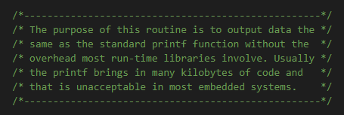

**5**

**5.1** The base address of the STDOUT and STDIN are all 0xE0001000.

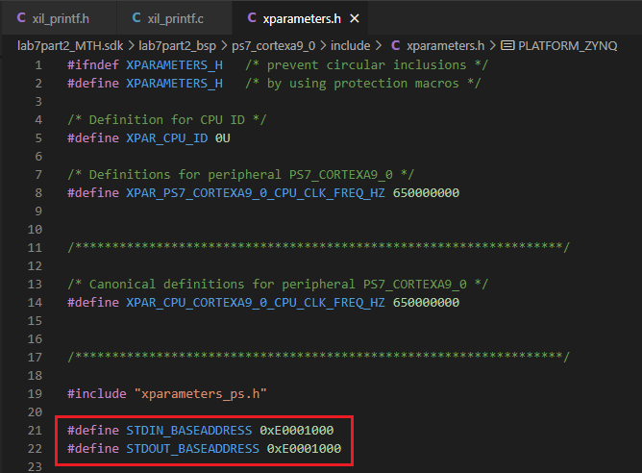

**5.2** The base address of UART1 is defined in file “xparameters.h”. The driver only need to include this file and get it.

**5.3** xil_printf() is no need to know where or which port to send its formatted character string. It is responsible for UART1 to do it. Xil_printf() just need to call the send and receive bytes function provided by UART1 driver.

**5.4** The xil_printf() converts the string firstly and call outbyte or outnum to send data.

**5.5** Blocking calls.

**5.6** xil_printf() call outbyte(), and outbyte() call XUartPs_SendByte() provided by Level 0 driver of uart device.

**6**

**6.1**

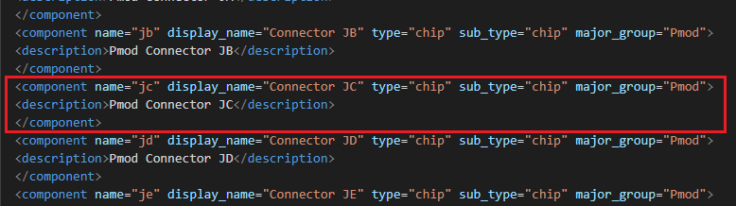

**6.2**

The connection is defined like this. A port_map unit defines a pair of connect relative.

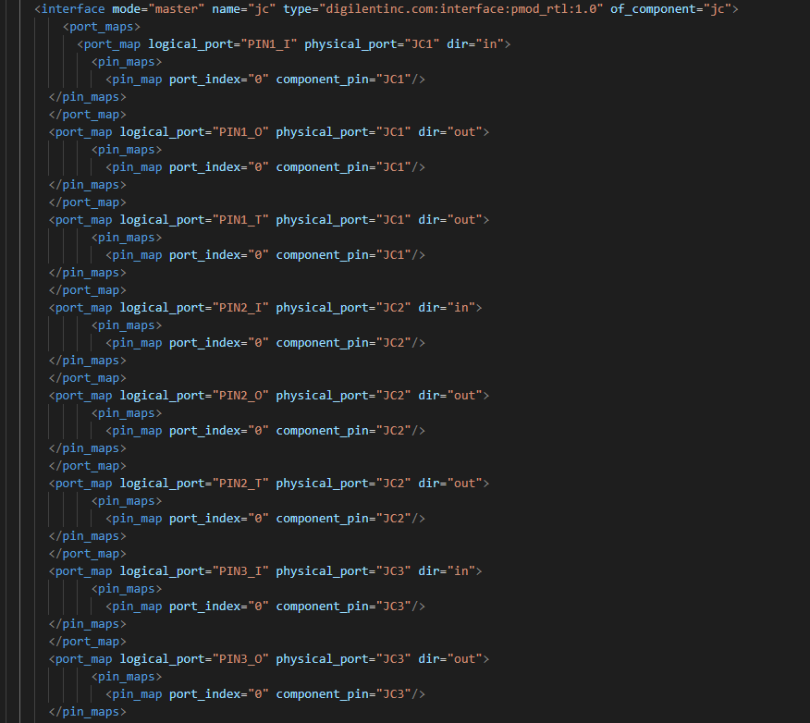

**6.3**

All interfaces are defined under the first component of part0 as below.

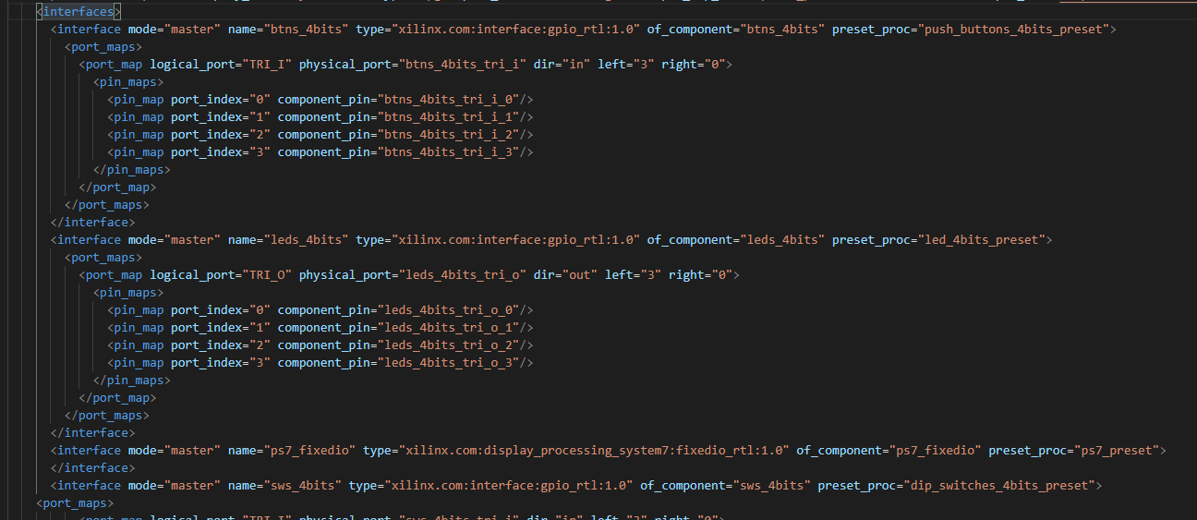

**6.4**

A pin unit describe a mapped between a logical and physical pin.

